
ADVANCED PROJECT REPORT
Design and Implementation of an ETL Pipeline with LLMAssisted Pipeline Generation for ECommerce Data Analysis
A Detailed Technical Report: System Design, Implementation, Code Walkthrough, and Comparative Evaluation of Manual vs. LLMAssisted ETL Pipelines on the Olist ECommerce Dataset
M.Sc. Data Engineering Advanced Project
Supervised by: Prof. Atit Bashyal
Prepared by: Renuka Joshi
Matriculation No : 30009626
Constructor University Bremen
August 2026

1. Introduction

1.1 Background
ETL (Extract, Transform, Load) pipelines are a core part of data engineering: they prepare raw data for analysis and downstream applications. Traditionally, building an ETL pipeline means a data engineer manually identifies the required datasets, writes extraction logic, cleans and transforms the data, joins datasets where necessary, stores the results, and validates the output. This gives full control but requires repeated programming effort every time a similar workflow is needed.
Large Language Models (LLMs) offer an alternative: instead of handwriting every pipeline step, a user can describe the required ETL workflow in plain natural language, and the LLM converts that description into a structured, executable workflow. This project builds and evaluates such a system an LLMassisted ETL pipeline generator using Google's Gemini API as the naturallanguagetopipeline engine, and Python/pandas as the actual dataprocessing engine.

1.2 Problem Statement
Developing ETL pipelines manually requires developers to understand dataset structure and implement extraction, transformation, joining, storage, and validation logic by hand. For every new requirement, similar development work is repeated, which increases effort and slows down experimentation. The problem addressed by this project is:
“Can a Large Language Model generate executable ETL workflows from naturallanguage requirements while maintaining dataquality results comparable to manually implemented ETL pipelines?”
The project also investigates the tradeoff between the additional time required for LLMbased pipeline generation and any reduction in manual workflowdevelopment effort.

1.3 Project Objectives
- Develop an LLMassisted ETL pipeline generation system using Gemini.
- Allow users to describe ETL requirements in natural language.
- Convert naturallanguage requests into structured, executable ETL pipeline definitions (JSON).
- Execute the generated pipeline using Python and pandas.
- Implement the standard ETL operations: LOAD, CLEAN, TRANSFORM, JOIN, STORE, VALIDATION.
- Implement equivalent manual ETL pipelines as a baseline for comparison.
- Compare manual and LLMassisted pipelines using measurable experiments.
- Evaluate dataquality consistency between the two approaches.
- Measure the runtime overhead introduced by LLMbased generation.
- Determine which technology (Python/pandas, SQL, or an orchestrator such as Airflow) is actually responsible for executing each operation.

1.4 Research Questions
To keep the evaluation focused and to directly address the technical questions raised during project review, the project is organized around four research questions:
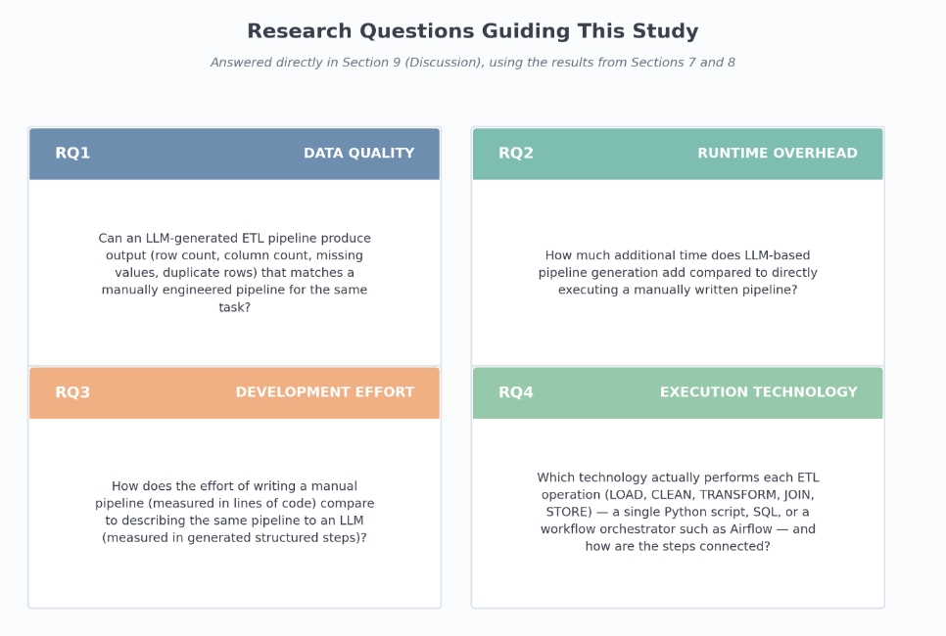

2. Dataset and Experimental Context

2.1 Olist ECommerce Dataset
The project uses the Olist Brazilian ECommerce dataset. The raw CSV files are stored in data/raw/ and represent five different parts of a real ecommerce transaction system. Each one plays a specific, different role in the experiments in Sections 6–7 not just an interchangeable input file:

Dataset | Rows | Explanation
Customers | 99,441 | One row per customer with their ID and location (zip code, city, state); joined to Orders via customer_id in Experiment 2.
Orders | 99,441 | The central transactional table one row per order with status and purchase/delivery timestamps; joined to Customers in Experiment 2.
Order Items | 112,650 | One row per item within an order (product, seller, price, freight); joined to Products via product_id in Experiment 1.
Payments | 103,886 | One row per payment record (type, installments, value); processed on its own in Experiment 3, with no join.
Products | 32,951 | One row per product with category and physical attributes (weight, dimensions, photos); the righthand table in Experiment 1's join.

2.2 Dataset Relationships
The five datasets are linked through foreignkey relationships: Orders references Customers through customer_id; Order Items and Payments both reference Orders through order_id; and Order Items references Products through product_id. These are exactly the join keys used throughout the project's experiments.
- Relationship type: All four relationships are onetomany. For example, one customer can have multiple orders, and one order can contain multiple order items.
- Orders as the hub: Orders is placed at the centre because it connects Customers, Order Items, and Payments through their respective keys.
- Payments and Order Items: Both connect to Orders using order_id, but they have no direct relationship with each other.
- Experiment coverage: The experiments use the Order Items–Products and Orders–Customers relationships. Payments is processed separately without a JOIN.
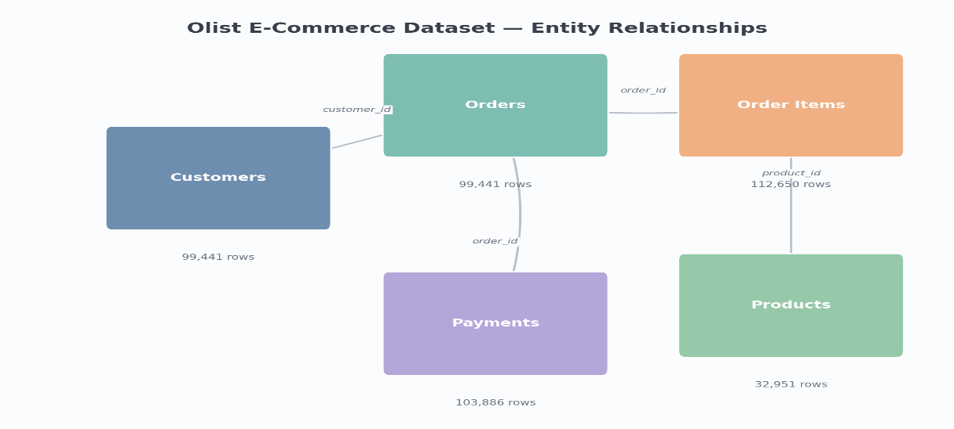
- Different row counts: Orders and Customers have 99,441 rows, Order Items has 112,650, and Products has 32,951, mainly because orders can contain multiple items and products can be reused across orders.

Figure 2.1 Entity relationships across the Olist datasets used in this project, with real row counts.
What this shows: This diagram maps the five raw CSV files to the foreign keys that connect them, drawn directly from the column headers in the raw data (customer_id, order_id, product_id). It exists to make the JOIN operations in Sections 5.4 and 6 concrete: Experiment 1 joins Order Items ↔ Products on product_id, Experiment 2 joins Orders ↔ Customers on customer_id, and Experiment 3 (Payments) uses no join at all. The row counts on each box are the actual sizes of the raw files, so this figure also anchors the numbers reported throughout Sections 7 and 8.

2.3 Data Quality Characteristics
Before any cleaning was applied, the raw datasets already contained no duplicate rows, but two of the five files contained missing values: the Products dataset had 2,448 missing cells (mainly in descriptive attributes such as product name length and photo count) and the Orders dataset had 4,908 missing cells (mainly in deliverydate columns for orders that were not yet delivered at the time the dataset was captured). The CLEAN operation (Section 5.2) resolves both to zero.
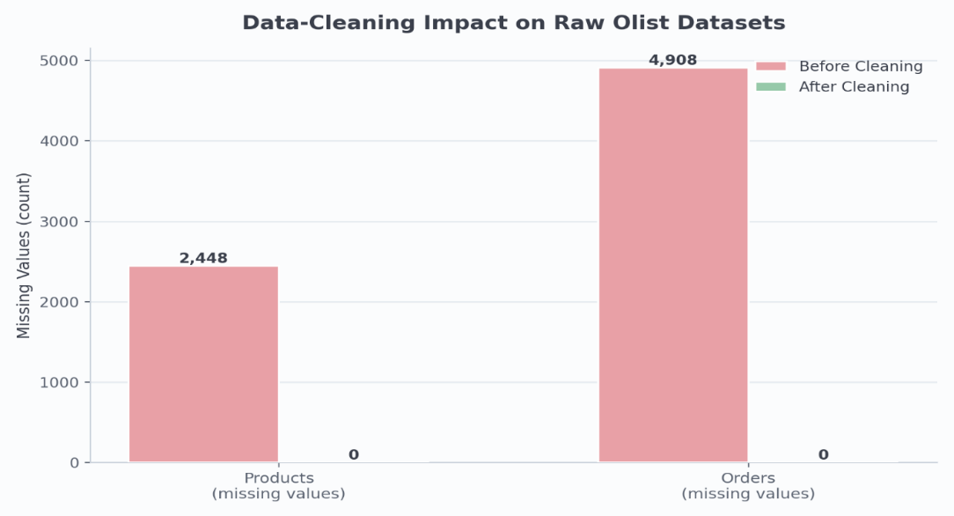

Figure 2.2 Missingvalue counts before and after the CLEAN step, measured directly on the raw Olist files.

What this shows: This chart is measured evidence, not an illustration: it was produced by counting df.isna().sum().sum() on the raw Products and Orders CSV files before any code in this project touched them, then again after running the CLEAN operation from Section 5.2. It demonstrates that the medianfill / emptystringfill cleaning rule genuinely resolves real missing data (2,448 cells in Products, 4,908 in Orders) to zero, rather than the “0 missing values” reported in every experiment table being trivially true because the data was already clean.

3. Proposed System

3.1 System Overview
The system follows a pipelinegenerationandexecution architecture. A user describes the ETL workflow they want in plain English. That request is turned into a prompt and sent to Gemini, which returns a structured JSON pipeline. The pipeline is validated, shown to the user for confirmation, and then executed step by step by a Python/pandasbased executor, which finally reports the output's dimensions and dataquality measurements.
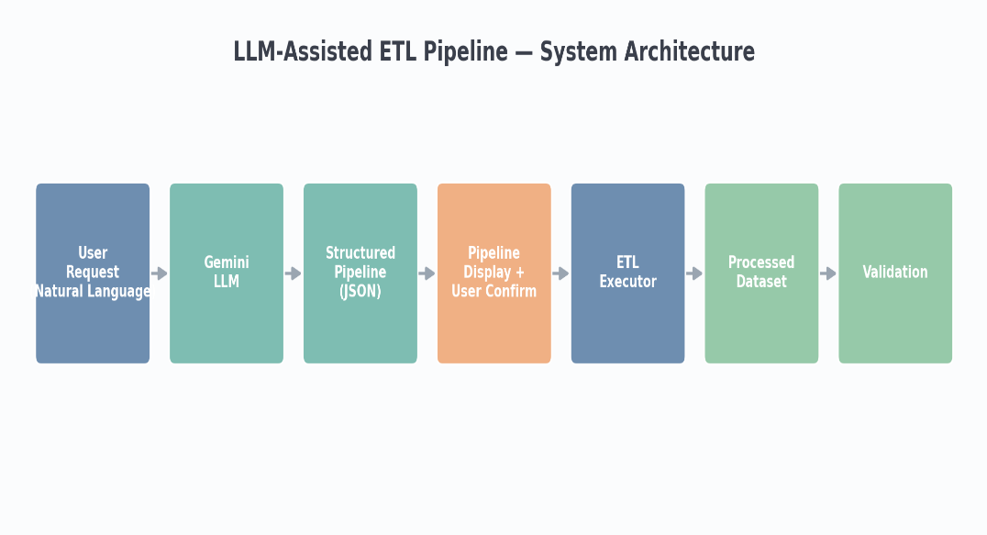

Figure 3.1 Endtoend system architecture, from naturallanguage request to validated output.

What this shows: This diagram is a visual index for Section 4: each box corresponds to one numbered subsection (4.1–4.7) and one concrete function call in the codebase e.g. “Gemini LLM” is GeminiAgent.ask(), “Structured Pipeline (JSON)” is the output of json.loads() inside generate_pipeline(), and “ETL Executor” is ETLExecutor.execute_pipeline(). It is included here, before the componentbycomponent breakdown in Section 3.2, so the reader has a map of how agent.py, pipeline_generator.py, and executor.py fit together before seeing each one's code.

3.2 System Components
The system is implemented as four cooperating Python modules inside the llm_agent/ package, plus a separate evaluation module. Each is described below with the actual implementation code.

3.2.1 LLM Agent (llm_agent/agent.py)
The Gemini Agent class is a thin wrapper around Google's genai client. On construction, it loads the GEMINI_API_KEY from a local .env file (using pythondotenv) and creates a genai.Client. Its only public method, ask(prompt), sends the prompt string to the configured Gemini model (gemini3.5flash) via client.models.generate_content(...) and returns the raw text response. This class has no awareness of ETL semantics it is purely a textin, textout LLM interface used by the PipelineGenerator.

3.2.2 Pipeline Generator (llm_agent/pipeline_generator.py)
The PipelineGenerator class turns a naturallanguage request into a validated Python dictionary. Its generate_pipeline() method (1) builds the prompt via build_pipeline_prompt(), (2) calls GeminiAgent.ask() to get Gemini's response, (3) strips Markdown code fences if Gemini added them, (4) parses the cleaned text with json.loads(), and (5) validates the resulting structure before returning it. Validation checks that the response is a JSON object, that it contains a pipeline_name and a nonempty steps list, that every step has an operation and a dataset, that the operation is one of the five supported values (LOAD, CLEAN, TRANSFORM, JOIN, STORE plus VALIDATION), and that every JOIN step declares both join_with and join_key. If any check fails, generate_pipeline() returns None and prints a diagnostic message rather than allowing an invalid pipeline through to the executor.
A separate method, display_pipeline(), prints the pipeline name, description, dataset list, and each step's operation/dataset/details (plus join_with/join_key for JOIN steps) to the console, which is what the user sees before deciding whether to confirm execution.

3.2.3 Prompt Design (llm_agent/prompts.py)

The Prompt Design component defines the instructions given to Gemini for generating ETL pipelines. The main PIPELINE_GENERATION_PROMPT restricts Gemini to the five available datasets and the defined operations: LOAD, CLEAN, TRANSFORM, JOIN, STORE, and VALIDATION. It also specifies the required parameters for JOIN operations and requires every generated pipeline to end with a VALIDATION step.

The prompt further instructs Gemini to return only raw JSON, without Markdown or additional explanation. This ensures that the response can be reliably parsed by json.loads() and passed to the PipelineGenerator and subsequently to the ETLExecutor.

Two additional prompt templates are provided for pipeline explanation and dataquality assessment, extending the system beyond pipeline generation.

3.2.4 ETL Executor (llm_agent/executor.py)
The ETLExecutor class performs the actual data processing. It defines a classlevel DATASET_FILES dictionary mapping each logical dataset name (e.g. "orders") to its raw CSV filename (e.g. olist_orders_dataset.csv), and resolves data/raw/ and data/processed/ relative to the project root at import time. Internally it keeps a dictionary of inmemory pandas DataFrames (self.dataframes) plus a self.final_result reference once a JOIN has produced a combined dataset. Its execute_pipeline() method is the dispatcher: it iterates over the pipeline's steps list in order and calls the corresponding method :load_dataset(), clean_dataset(), transform_dataset(), join_datasets(), store_result(), or validate_result() based on each step's
Every individual operation (LOAD, CLEAN, TRANSFORM, JOIN, STORE, VALIDATION) is implemented as its own method on ETLExecutor using pandas; the detailed behaviour of each is covered in Section 5.

3.2.5 Evaluation Module (evaluation/)

The evaluation module records and analyzes the results of the manual and LLMassisted experiments without running the pipelines itself.

Record: compare_results.py stores the measured results in experiment_results.csv.

Analyze: analyze_results.py calculates averages and exact match rates for rows, columns, missing values, and duplicates.

Visualize: plot_results.py uses the recorded results to generate comparison charts.

Workflow: Record → Analyze → Visualize

Separation: The evaluation module is independent from both ETL implementations, so it only analyzes the results produced by the experiments.

Timing: The reported timings come from individual pipeline runs and are manually recorded for analysis; repeated runs may produce slightly different execution times.

4. LLMAssisted ETL Workflow
This section walks through the complete, actual control flow implemented in main.py, from the moment the user types a request to the moment results are printed. This is the concrete answer to “how does the agent work in detail” and “how are the steps connected to each other” each stage below is a specific function call in the codebase, in the order it actually executes.

4.1 User Requirement
main.py prints the five available dataset names and an example request, then calls Python's builtin input() to collect a freetext requirement, for example:
“Load orders, clean missing values, join with customers, and store the result.”
If the input is empty, the program exits immediately; otherwise the raw string is passed unmodified into the next stage.

4.2 Prompt Generation
PipelineGenerator.generate_pipeline() calls build_pipeline_prompt(user_request) from prompts.py, which substitutes the user's text into the {user_request} placeholder at the bottom of PIPELINE_GENERATION_PROMPT (Section 3.2.3, Code 3.3). The result is one long, fullyspecified prompt string containing the dataset list, the operation rules, the required JSON schema, and the user's own words this is what is sent to Gemini.

4.3 Gemini Pipeline Generation
The completed prompt is passed to GeminiAgent.ask() (Section 3.2.1, Code 3.1), which calls client.models.generate_content(model="gemini3.5flash", contents=prompt) and returns response.text the model's raw textual answer. main.py measures this call's duration with time.perf_counter() before and after; this is the “LLM Generation Time” reported in every experiment in Section 7.

4.4 JSON Pipeline
Back in generate_pipeline(), the raw response text is stripped of leading/trailing whitespace, and any ```json / ``` Markdown fences are removed if Gemini added them despite being instructed not to. The cleaned string is then parsed with Python's json.loads(), turning it into a nested dictionary with pipeline_name, description, datasets, and a steps list each step itself a dictionary with step_number, operation, dataset, and (for JOIN steps) join_with and join_key. The example below illustrates the structure that the prompt schema (Code 3.3) defines and that the executor (Section 3.2.4) consumes.

4.5 Pipeline Validation
Once parsed, the dictionary is passed through the structural validation described in Section 3.2.2 (Code 3.2): every step must have an operation and a dataset, the operation must be one of the five supported values, and JOIN steps must declare join_with and join_key. Any failure returns None to main.py, which prints “Pipeline generation failed.” and exits the pipeline never reaches the executor unless it passes every check.

4.6 User Confirmation
If validation succeeds, generator.display_pipeline() prints the full stepbystep plan to the console (Section 3.2.2). main.py then calls input("Do you want to execute this pipeline? (yes/no): ") and only proceeds to execution if the user types “yes” or “y” any other answer cancels the run before a single row of data is touched.

4.7 Pipeline Execution
On confirmation, main.py creates a fresh ETLExecutor() and calls executor.execute_pipeline(pipeline), timed separately from the generation step this is the “ETL Execution Time” reported in Section 7. The dispatcher (Code 3.4) walks the steps list in the order Gemini produced it and calls the matching pandasbased method for each operation (Section 5). After the loop finishes, main.py prints the LLM generation time, ETL execution time, and their sum (“Total LLMAssisted Time”).

5. ETL Operations and Implementation
This section explains what each ETL operation actually does in the codebase not the textbook definition, but the specific pandas code executed by ETLExecutor for every generated pipeline. All six operations are implemented as methods on the same class and run in the same Python process; no SQL engine or external orchestrator is involved (see Section 9.4 for the full technology discussion).

5.1 LOAD
- load_dataset(dataset) looks up the requested logical name (e.g. "products") in the DATASET_FILES dictionary to find its actual CSV filename, builds the full path under data/raw/, raises FileNotFoundError if the file is missing, and otherwise reads it with pd.read_csv(path). The resulting DataFrame is stored in self.dataframes[dataset] so later steps (CLEAN, TRANSFORM, JOIN) can find it by name, and the number of loaded rows is printed for visibility.
- Dataset mapping: DATASET_FILES connects logical dataset names to their CSV files in data/raw/.
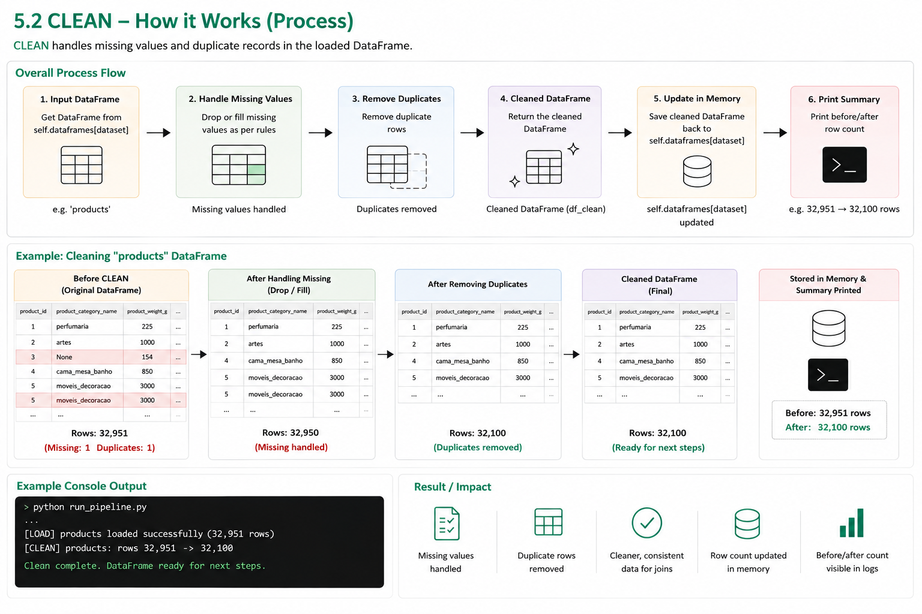
- File check: load_dataset() verifies that the required file exists before loading it.
- DataFrame creation: pd.read_csv() loads the file into a pandas DataFrame stored in self.dataframes.
- Pipeline connection: The loaded DataFrame is passed to the CLEAN, TRANSFORM, and JOIN stages.
- Experiment example: In Experiment 1, order_items and products are loaded and then prepared for the product_id JOIN.

5.2 CLEAN

The CLEAN stage prepares the loaded DataFrame by handling duplicate records and missing values. clean_dataset() first records the initial row count, missing values, and duplicate rows to measure the effect of cleaning.

It removes duplicates using df.drop_duplicates(). Missing values in numeric columns are filled with the column median, while nonnumeric columns are filled with an empty string; 0 is used when a median cannot be calculated.This process resolved the 2,448 missing values in Products and 4,908 in Orders, resulting in zero missing values in the processed datasets.
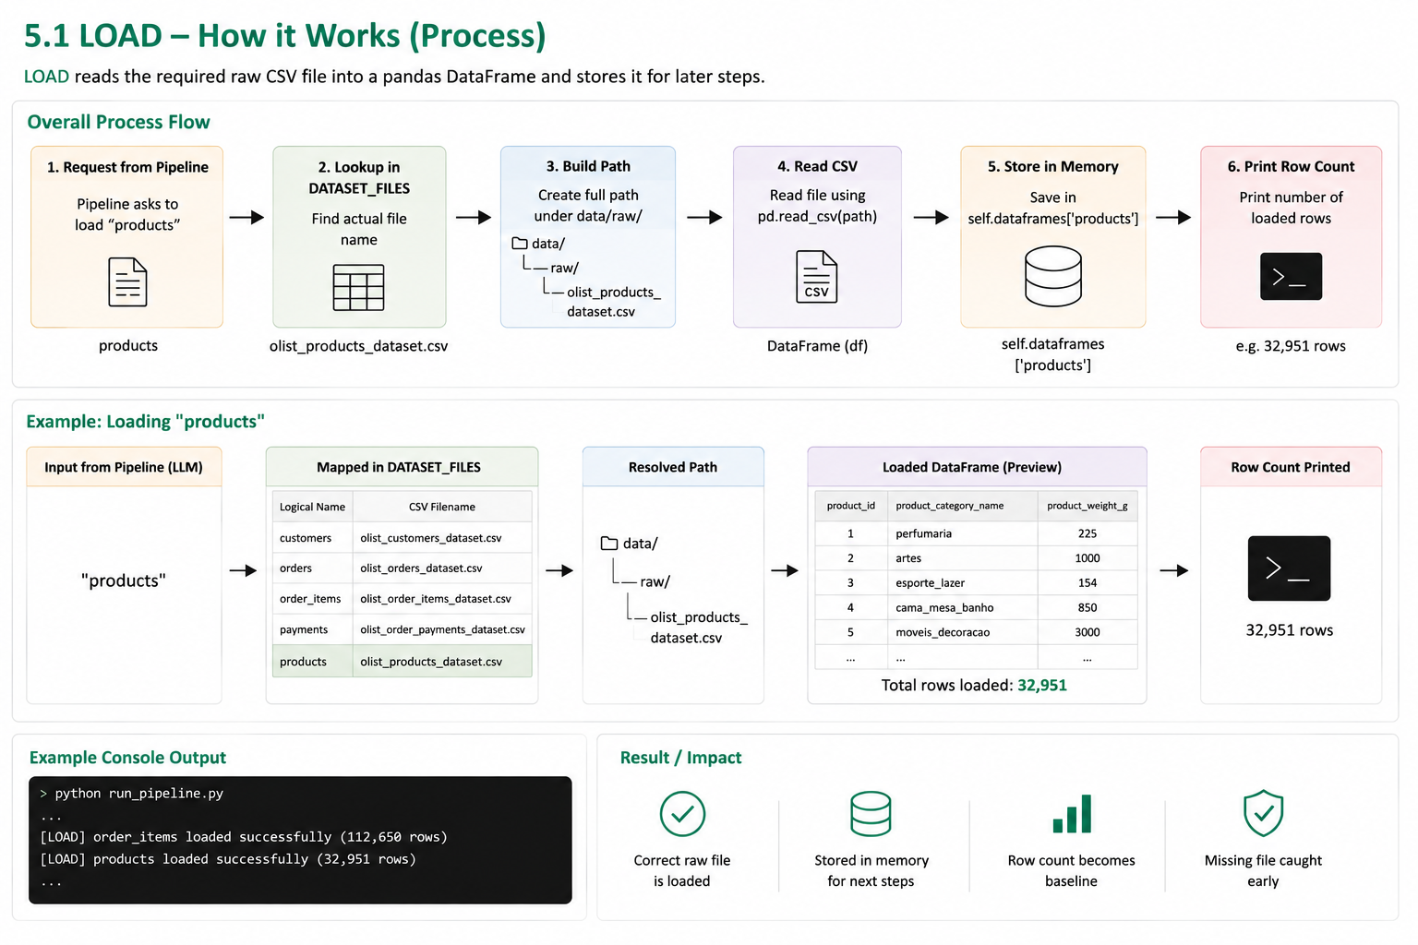

- Input: Takes the DataFrame loaded by the LOAD step.
- Missing values: Drops or fills missing values according to the pipeline configuration.
- Duplicates: Uses drop_duplicates() to remove repeated records.
- Update: Stores the cleaned DataFrame back in self.dataframes[dataset].
- Check: Prints beforeandafter row counts to show the effect of cleaning.

5.3 TRANSFORM

The TRANSFORM stage applies datasetspecific datatype conversions using pd.to_datetime() for date fields and pd.to_numeric() for numeric fields. The errors="coerce" option converts invalid values to NaT or NaN without stopping the pipeline.

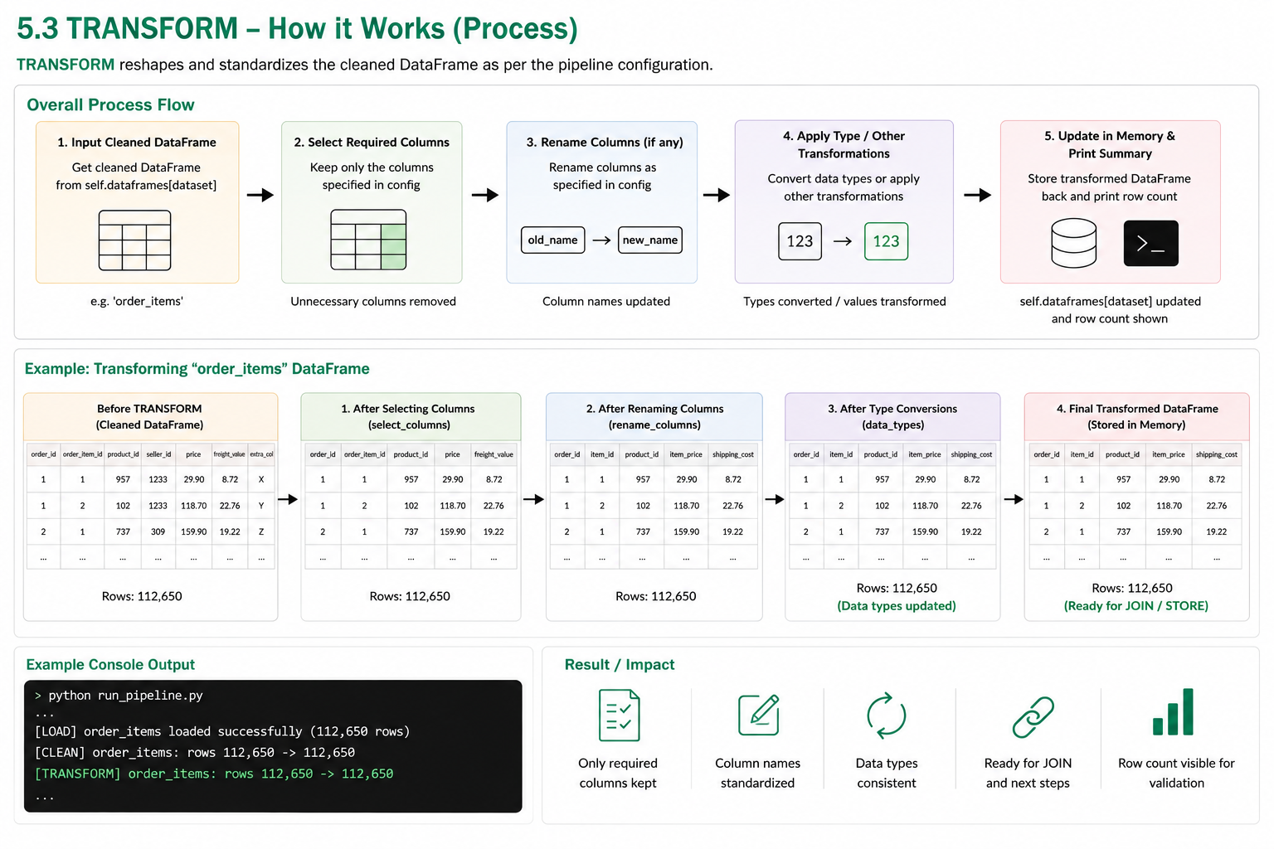
For Orders, the relevant date columns are converted to datetime, while Payments, Order Items, and Products receive the required numeric conversions. Customers requires no additional transformation.The transformed DataFrame is then passed to the JOIN, STORE, or VALIDATION stage

- Input: Takes the cleaned DataFrame from the CLEAN step.
- Column selection: Keeps only the columns specified in the generated pipeline.
- Renaming: Renames columns when required for a consistent structure.
- Transformation: Applies required changes such as datatype conversions using pandas.
- Update: Stores the transformed DataFrame back for the JOIN or STORE stage.

5.4 JOIN
The JOIN stage combines two processed DataFrames using a common key. join_datasets() checks that both datasets and the specified join key are available, then converts the join columns to string type using .astype(str) to ensure compatible data types.
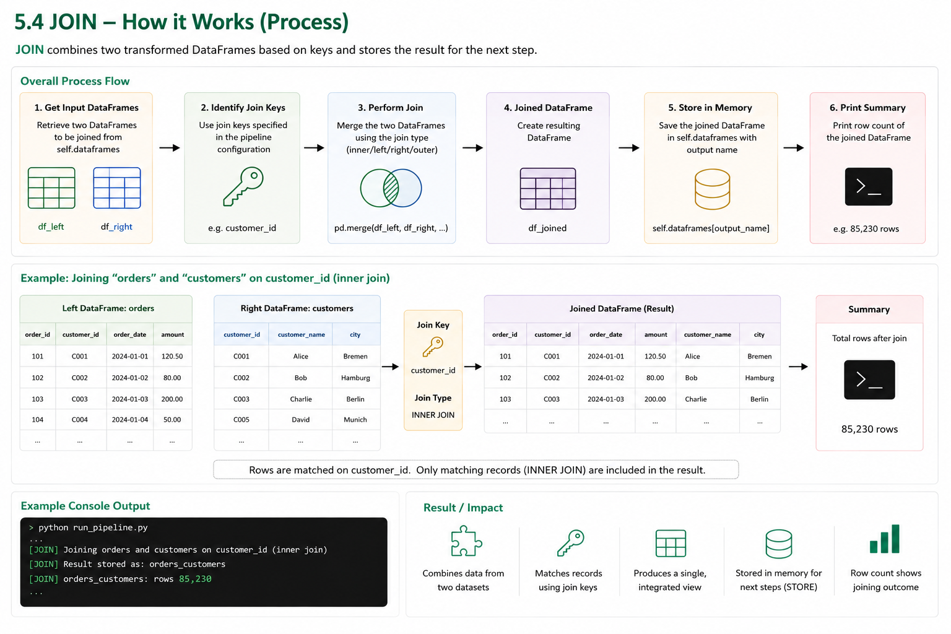
The executor uses pd.merge() with an inner join, keeping only matching records from both datasets. The merged result is stored in self.final_result and passed to the STORE and VALIDATION
- Prepare inputs: The executor retrieves the required DataFrames that were loaded and processed in the earlier steps.
- Select join key: The pipeline specifies the common key, such as customer_id or product_id, to connect the two datasets.
- Merge datasets: pd.merge() combines the DataFrames according to the specified join type and key, producing one integrated DataFrame.
- Store and verify: The joined DataFrame is stored for the next ETL step, and the resulting row count is checked to confirm the join outcome.

5.5 STORE
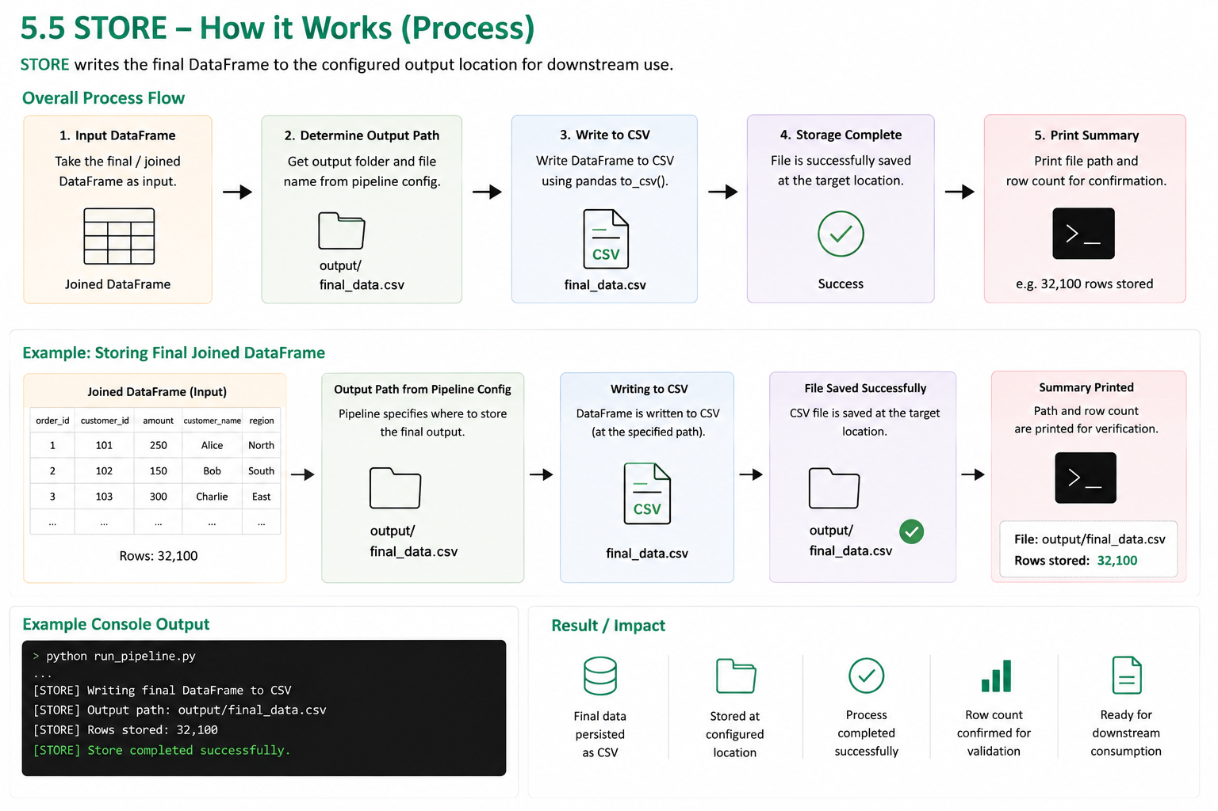
- store_result(pipeline) takes whatever DataFrame is currently the “current result” (the joined result if a JOIN happened, otherwise the last loaded/cleaned dataset) and writes it to data/processed/ as a CSV file. The output filename is derived automatically from the pipeline's dataset list: a single dataset produces “{dataset}.csv”, two datasets produce “{dataset1}_{dataset2}.csv” (e.g. order_items_products.csv), and three or more fall back to final_result.csv.

Receive output: The final processed or joined DataFrame is taken as the input for storage.
- Set output path: The pipeline specifies the required output location and filename.
- Write data: The DataFrame is saved as a CSV file using pandas to_csv().
- Confirm storage: The executor confirms that the output file has been successfully created at the specified location.
- Report result: The file path and number of stored rows are printed, making the final output easy to verify.

5.6 VALIDATION
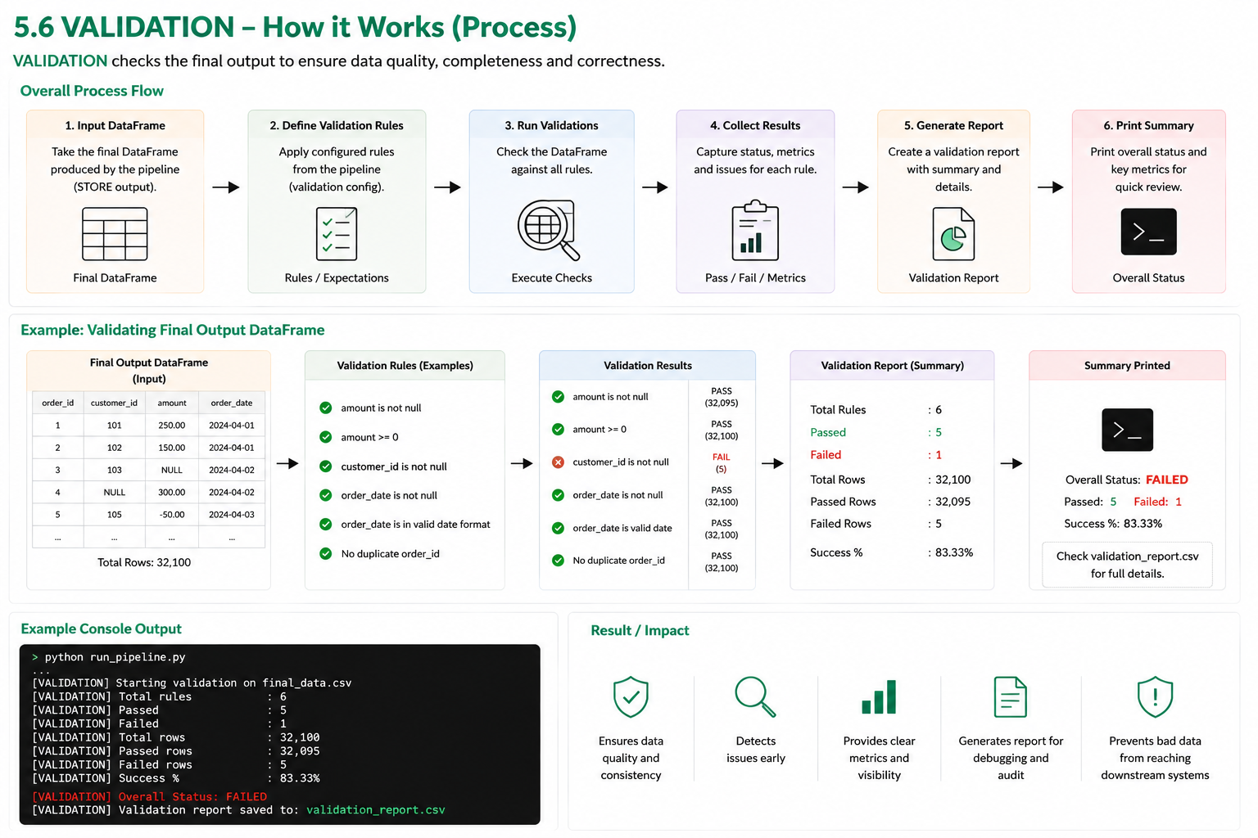
validate_result() is always the final step: it computes final rows, columns, missing values, and duplicates, then prints “Validation completed successfully” only if missing values and duplicates are both zero. This is the source of every quality figure reported in Section 7.

- Input: Takes the final DataFrame produced by the ETL process.
- Structure check: Records the final row and column counts.
- Quality check: Checks for missing values and duplicate records.
- Validation summary: Combines the calculated metrics into a final result.
- Output: Displays the validation status and metrics for review and comparison.

6. Manual ETL Baseline
Each of the three experiments has an independent, linear Python script under evaluation/manual_pipeline/ using pandas directly no LLM, no JSON, no class structure. Cleaning uses drop_duplicates() → ffill() → dropna() (slightly different from the executor's medianfill rule), and joins use how="left" rather than "inner".
- manual_etl.py (Exp. 1) joins order_items + products on product_id → 112,650 rows × 15 columns.
- manual_orders_customers.py (Exp. 2) joins orders + customers on customer_id → 99,441 rows × 12 columns.
- manual_payments.py (Exp. 3) no join; converts numeric columns → 103,886 rows × 5 columns.

7. Experiments

A. Experimental Methodology

A.1 Experimental Design
Three experiments cover the structurally different workflows possible: two twodataset joins (order_items+products; orders+customers) and one singledataset transform (payments) each run once manually and once via the LLMassisted pipeline, on the same input files.

Experiment | Workflow | Datasets | Join Key
1 | Order Items + Products | 2 | product_id
2 | Orders + Customers | 2 | customer_id
3 | Payments | 1 | (no join)

A.2 Experimental Procedure
Each manual script timed itself internally with perf_counter(); main.py timed LLM generation and execution separately. All six measurements were then recorded by hand into compare_results.py, which analyze_results.py aggregates into averages and match rates. Rerunning the code will produce similar but not identical timings (LLM latency and system load vary), though the dataquality figures are deterministic.

A.3 Evaluation Metrics
- Manual execution time (seconds) measured inside each manual script.
- LLM generation time (seconds) time for Gemini to return a pipeline, measured in main.py.
- LLM ETL execution time (seconds) time for ETLExecutor to run the generated steps.
- Development effort manual code lines (source file line count) vs. LLM pipeline steps (length of the generated steps list).
- Final rows / final columns shape of the stored output dataset.
- Missing values / duplicate rows computed by validate_result() (LLM) or the equivalent manual validation block.
- Pipeline status SUCCESS if the script/pipeline completed without a runtime exception; used for the pipeline success rate in Section 8.4.

B. Experimental Results
All three experiments produced identical manual vs. LLM output on every dataquality metric:
Experiment | Manual Time | LLM Gen / Exec | Lines / Steps | Rows × Cols | Miss. / Dup. | Status
1 Items+Products | 1.9394 s | 7.68 s / 2.69 s | 173 / 7 | 112,650 × 15 | 0 / 0 | SUCCESS / SUCCESS
2 Orders+Customers | 2.1229 s | 9.98 s / 4.50 s | 181 / 7 | 99,441 × 12 | 0 / 0 | SUCCESS / SUCCESS
3 Payments | 0.4619 s | 13.31 s / 0.75 s | 152 / 5 | 103,886 × 5 | 0 / 0 | SUCCESS / SUCCESS

Request used per experiment: (1) “Clean order_items and products, join on product_id, save the result”; (2) “Load orders and customers, clean, join on customer_id, store”; (3) “Load payments, clean, convert numeric columns, save.” Every foreign key had a match on both sides, so the LLM's inner join and the manual left join produced identical row counts in all three cases.

8. Comparative Analysis

8.1 Performance
Across all three experiments, the manual scripts executed faster in raw terms because they skip the LLM call entirely. The LLMassisted pipeline's total time is dominated by Gemini's response latency rather than by the pandas operations themselves the actual ETL execution step (once the pipeline JSON exists) is comparable in order of magnitude to the manual scripts.
Metric | Average
Manual ETL execution | 1.5081 s
LLM generation | 10.3272 s
LLM ETL execution | 2.6504 s
LLM total time | 12.9776 s
Additional LLM overhead | 11.4696 s
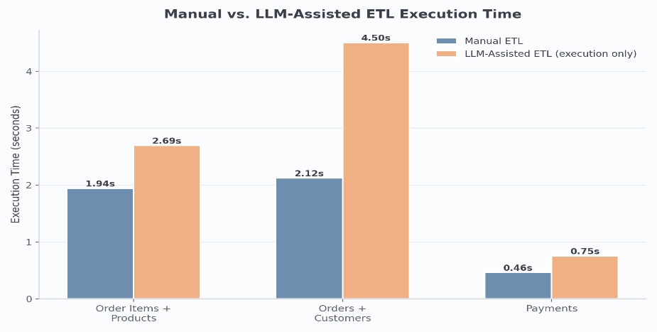

Figure 8.1 Manual vs. LLM ETL execution time (Gemini call excluded).
What this shows: This isolates just the dataprocessing time the manual script's total runtime against the LLM executor's execute_pipeline() call alone, with the Gemini network call excluded from both bars. It shows that even without the LLM overhead, the LLMassisted executor is somewhat slower per experiment (e.g. 2.69 s vs. 1.94 s in Experiment 1), most likely because of its extra validation and printstatement overhead compared to the leaner manual scripts.
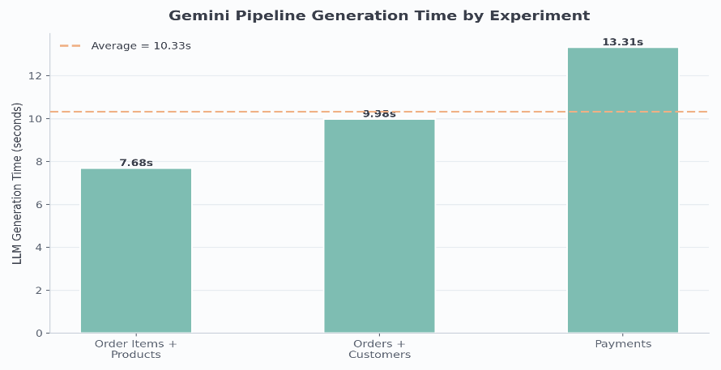

Figure 8.2 Gemini pipelinegeneration time by experiment.

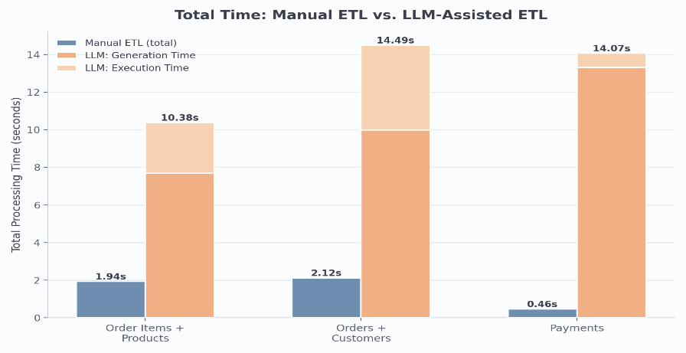
What this shows: This isolates the one component that the manual pipeline has no equivalent for at all: the network roundtrip to Gemini inside GeminiAgent.ask(). It shows generation time ranging from 7.68 s to 13.31 s and is not correlated with dataset size (Payments, the smallest dataset, has the longest generation time) evidence that this delay is driven by the LLM service's response latency, not by the ETL workload itself.

Figure 8.3 Total time: manual (single measurement) vs. LLM generation + execution (stacked).
What this shows: This combines Figures 8.1 and 8.2 into the full picture a user actually experiences: the manual bar is the script's total runtime, and the LLM bar stacks generation time (bottom) on top of execution time (top) to match the “Total LLMAssisted Time” printed by main.py (Code 4.2). It is the chart most directly answering RQ2 (Section 9.3) how much slower is the LLMassisted path endtoend.

8.2 Development Effort

Manual code length ranged from 152 to 181 lines per experiment (average 168.67), while the LLMgenerated pipelines ranged from 5 to 7 structured steps (average 6.33). These are different units a line of imperative Python is not equivalent to one declarative JSON step but the comparison illustrates that the same ETL logic that took roughly 150–180 lines to handwrite could be fully specified by a twosentence naturallanguage request plus Gemini's structured output

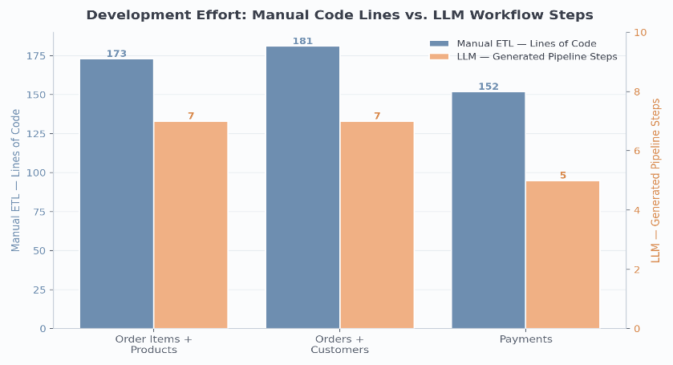

Figure 8.4 Manual lines of code vs. LLMgenerated pipeline steps, per experiment

What this shows: This plots two different units on twin axes deliberately, rather than forcing a false direct comparison: the navy bars are the actual line count of each manual_*.py script (152–181 lines), and the orange bars are the length of the steps list inside the generated pipeline JSON (5–7 steps). It exists to support RQ3 (Section 9.4) the point is not that “7 is smaller than 173” in an absolute sense, but that the same outcome was fully specified in a naturallanguage sentence instead of a handwritten script.

8.3 Data Quality
Row count, column count, missingvalue count, and duplicaterow count matched exactly between the manual and LLMassisted outputs in all three experiments a 100% match rate on every metric.
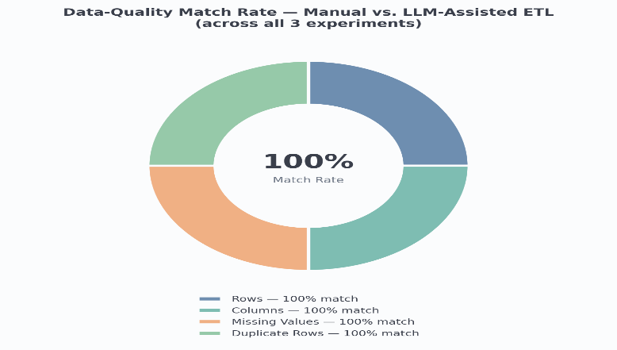

Figure 8.5 Dataquality match rate across all three experiments.
What this shows: Each of the four segments is computed in analyze_results.py as the percentage of experiments (out of 3) where the manual and LLM columns in experiment_results.csv are exactly equal e.g. rows_match_rate = (df.manual_rows == df.llm_rows).mean() * 100. All four came out at 100% here, meaning manual_rows equalled llm_rows, manual_columns equalled llm_columns, and so on, in every single one of the three experiments, not just on average.

8.4 Pipeline Success
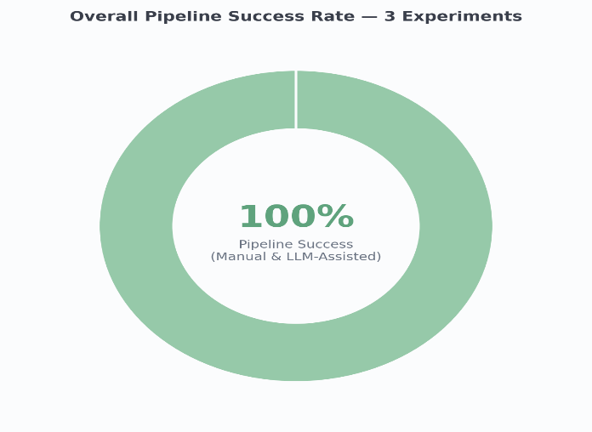
Both the manual and the LLMassisted pipeline reported SUCCESS in all three experiments a 100% success rate for each approach. In this project, “SUCCESS” specifically means the script or pipeline ran to completion without raising a Python exception, and its VALIDATION step reported zero missing values and zero duplicate rows on the final output. The fact that the manual and LLMassisted numbers are identical in every experiment (Section 7.B) means the two implementations are not just both “working” in isolation they produced functionally equivalent output datasets for the same input data and the same requested transformation, which is the strongest available evidence that the LLM correctly translated the naturallanguage request into the intended ETL logic.
Figure 8.6 Overall pipeline success rate (manual and LLMassisted) across the three experiments.

What this shows: This visualizes the manual_success_rate and llm_success_rate values from analysis_summary.csv the fraction of runs where the script/pipeline finished without raising an exception. Both reached 100% here because every one of the six runs (three manual, three LLMassisted) completed and printed its final validation summary rather than crashing partway through; the precise meaning of “success” is spelled out in the paragraph above (Section 8.4).

9. Discussion

9.1 Findings
The LLMgenerated pipelines were dataqualityequivalent to the manual baseline in every experiment, but not faster adding 11.47 s of overhead on average. The LLM's real value is expressive: 150+ lines of handwritten code reduced to one naturallanguage sentence.

9.2 RQ1 Data Quality
Yes, within these three experiments: 100% match rate on rows, columns, missing values, and duplicates (Section 8.3) despite the LLM executor using an inner join where manual scripts use a left join (Section 5.4). This is a datasetspecific result (every key matched on both sides), not a general guarantee that inner and left joins are interchangeable.

9.3 RQ2 Runtime Overhead
An average of 11.4696 s per pipeline (Section 8.1), driven by Gemini's response latency rather than dataset size proportionally more costly for small, fast jobs like Payments.

9.4 RQ3 Development Effort
168.67 manual lines vs. 6.33 LLM steps on average (Section 8.2) nonequivalent units, but describing the requirement in one or two sentences reproduced logic that otherwise required a dedicated script.

9.5 RQ4 Execution Technology
Every operation, in both pipelines, runs as pandas code in a single Python process. No SQL engine and no orchestrator (e.g. Airflow) is used anywhere Gemini's only role is producing the JSON specification of which pandas operations to run. Steps are connected by plain Python control flow: execute_pipeline() iterates the steps list in a single for loop (Code 3.4); there is no scheduler or DAG. LOAD precedes CLEAN/TRANSFORM (data must exist first); those precede JOIN (both sides must be ready); STORE/VALIDATION come last (they need the final result).
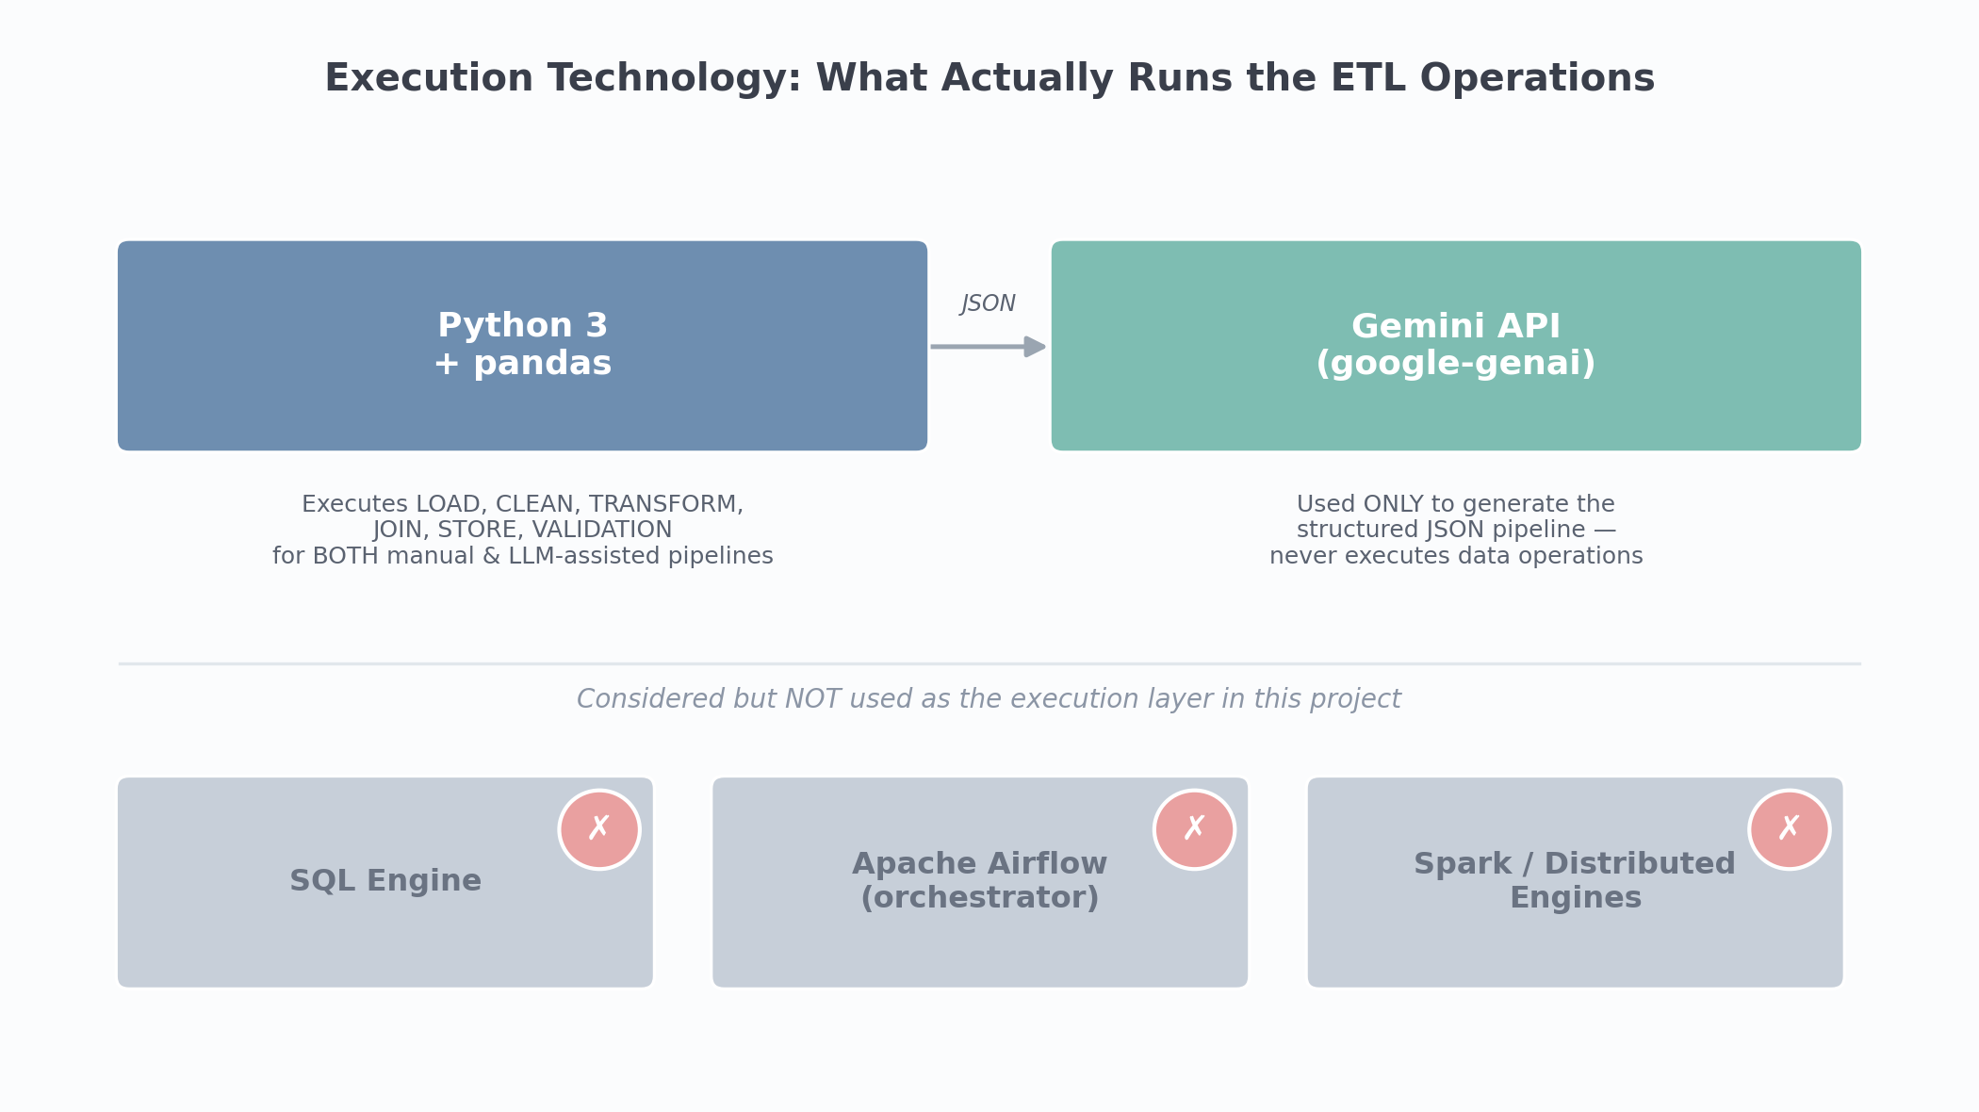
Figure 9.1 Execution technology: Python/pandas runs everything; Gemini only generates JSON; SQL/Airflow/Spark are not part of the execution path.
What this shows: Directly answers the “Python, SQL, or Airflow?” question no import, connection string, DAG file, or SQL query for any of these appears anywhere in the codebase.

10. Limitations
- Only three experiments were run, covering two joins and one singledataset transform results may not generalize to more complex, multiway joins.
- LLM generation time depends on Gemini's live latency and will vary between runs; figures are singlerun measurements, not averaged over repeated trials.
- The manual baseline uses a left join while the LLM executor uses an inner join by default they matched here only because every key had a match on both sides.
- Timing data was compiled by hand from individuallyrun scripts, not a single repeatable automated benchmark.
- Validation checks row/column/missing/duplicate counts only not schema types, referential integrity, or statistical distribution shifts.

11. Conclusion
This project built and evaluated an LLMassisted ETL generator (Gemini + pandas) against a manually engineered baseline across three ecommerce workflows. Every operation, in both paths, runs as pandas code in a single Python process; Gemini's role is limited to translating natural language into a JSON specification of operations.
The LLMgenerated pipelines matched the manual baseline exactly on every dataquality metric and completed with the same SUCCESS status in all three experiments. The LLMassisted approach was not faster it added an average of 11.47 s of generation overhead but reduced the code a user needed to write from 150+ lines to one naturallanguage sentence.
Naturallanguagedriven ETL generation is therefore technically viable and dataqualityequivalent to manual implementation for the tested scenarios, with its principal benefit being accessibility and reduced development effort rather than raw execution speed.

12. References
- Olist Brazilian ECommerce Dataset. Kaggle.
- Python Software Foundation. Python Documentation.
- The pandas development team. pandas: Python Data Analysis Library.
- Google. Gemini API Documentation (googlegenai Python SDK).
- Kimball, R. and Caserta, J. The Data Warehouse ETL Toolkit.

13. Appendix

A. Project Structure
- data/ raw/ (5 Olist CSVs) and processed/ (pipeline outputs)
- llm_agent/ agent.py, pipeline_generator.py, prompts.py, executor.py
- evaluation/manual_pipeline/ manual_etl.py, manual_orders_customers.py, manual_payments.py
- evaluation/ compare_results.py, analyze_results.py, plot_results.py, results/
- main.py LLMassisted pipeline entry point (Section 4)

B. Note on Generated Pipeline Logs
The submitted project's outputs/generated_pipeline.py and execution_logs.txt were empty, so the JSON structure in Section 4.4 is reconstructed from the prompt schema (Code 3.3) and the executor's accepted operations (Section 5), not copied from a captured run.
Git Repo link:
renukajoshi3110/LLM-Assisted-ETL-Pipeline: Design and Implementation of an ETL Pipeline with LLM-Assisted Pipeline Generation for E-Commerce Data Analysis

Thank you.

